Joel Lantigua

Linux Administrator

Installing Docker on CentOS

12/10/22

CentOS Docker

First thing I did before starting was switch into the root user by using su – root. next I used the command sudo yum install -y yum-utils which allows me to get the config manager so I can set up the docker repository. Once that was installed, the next command I used was **sudo yum-config-manager \ --add-repo \ https://download.docker.com/linux/centos/docker-ce.repo** This command allows me to set up the repository for docker.

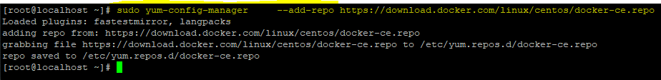

After I had the repository set up, I now need to install the Docker engine. To do so I used the command **sudo yum install docker-ce docker-ce-cli containerd.io docker-compose-plugin** which allowed me to install the latest version of docker. After the docker engine was successfully installed I then started the docker service by using the command **sudo systemctl start docker.** Lastly I had to check if docker was working correctly by using the command **sudo docker run hello-world.** This command runs the hello world image using docker also letting me know if docker is successfully running.

Work cited

<https://docs.docker.com/engine/install/centos/>